Learning Circle Group: Computer Chronicles-Elementary
Sponsoring Teacher: Irina Volynets
Sponsor School: Slonim gymnasia 1
City: Slonim
Country: Belarus

Name of Project: Forest Encyclopedia “Wonders of the forest”
Goal Of The Project:
To motivate children to investigate their local forests (that is animals, plants, insects, birds) and compare them with the other forests.
Keeping forests clean and planting trees together is another idea we are going to suggest as we are a ENO school and we’d like you to join us on ENO Tree Planting Day on May 21, 2010

Type Of Writing Requested: essays (word documents), drawings, photos(jpg), presentations

What You Are Looking For From Other Schools:
30 % of the Earth surface is covered by forests and forests play an important role in our life. They are full of wonders which we sometimes can’t notice. We’d like you to do a research and tell about different species of animal, birds and insects that inhabit your forests, about different species of plants (trees, flowers, grasses) that grow there.

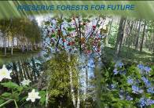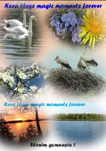

Questions to answer:

- What kind of forests are there in your area and country?
- What animals live there?
- What plants grow there?
- Are there any endangered animals?
- What can we do to save forests?
You can also make a quiz about the wildlife in your area.

We are looking forward to 4 articles : about one or two species of animals, about one or two species of birds, one or two insects and one or two plants.

Deadline For Receiving Information: (Circle deadline is December 5, 2010)

