Here are the questions these students answered

- What kind of forests are in Nebraska?
- What animals live in these forests?
- What plants grown in these forests?
- Are there endangered animals in Nebraska?
- What can we do to save forests in general?

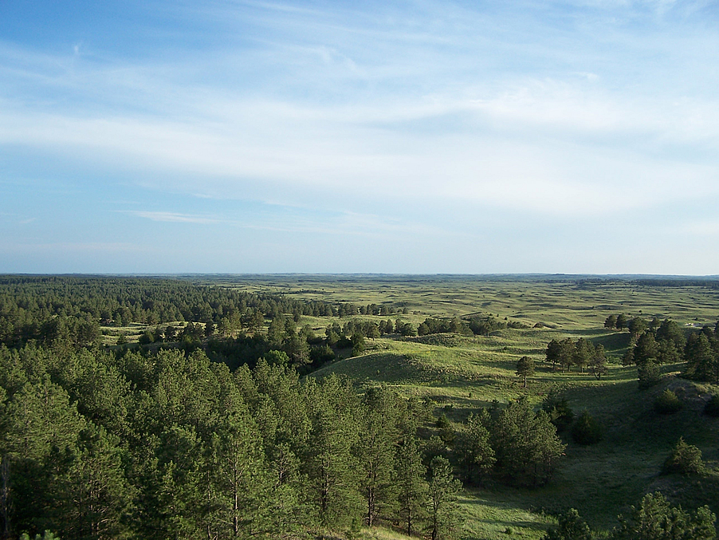
Matt
1. We have a forest called the Nebraska national forest. It is 142,000 acres long. It is the biggest forest in Nebraska. The rest of Nebraska is mostly a grass land and marsh type of land
2. A lot of animals live in forests. Usually foxes, birds, etc. Our state bird sometimes lives in the big forests or in grasslands. It is the Western meadowlark .
3. Flowers are a big thing in Nebraska. We have flowers like sunflowers. We also can grow crops like corn in grasslands.
4. Yes there are many endangered species in Nebraska. One of the species is buffalo. They live on the west part of Nebraska. They are mostly raised like cattle, not just in the wild.
5. We save forests by cleaning. We need to save forests for paper and trees and wild life. Also stopping wild fires in forests.

Brianna

1. We don’t have a lot of forests but these are some of the native trees in Nebraska, Ponderosa Pine, and Eastern Cottonwood, Common Hackberry, Black Walnut, Bur Oak.
2. Some animals that live in Nebraska are butterflies, rabbits, squirrels, eagles, geese, turkeys, and deer.

3. Some plants that live in Nebraska are grass, corn, soybeans, green beans, wheat, and trees.
4. Some endangered animals are beetle, crane, curlew, bald eagle, ferret, plover, shiner, sturgeon, and a tern.
5. Some ways to save the environment is to pick up trash, don’t pollute.

Ben
The types of trees in Nebraska are Coniferous and Deciduous
The animals that live in Nebraska are unique because we have a lot of bunnies, butterflies, deer, fish, ducks, birds, and farm animals. Sometimes we hunt animals for food.
The plants that grow in Nebraska are a Goldenrod which is our state plant. There are prickly pear plants which is a pear growing on a cactus. We have a lot of grass so we have a lot of farming. And then Sun Flowers that grow naturally.
An animal that lives in Nebraska that is endangered is a Black Footed Ferret. Another one is a swift fox. Or an Eskimo Curlew that is a bird.
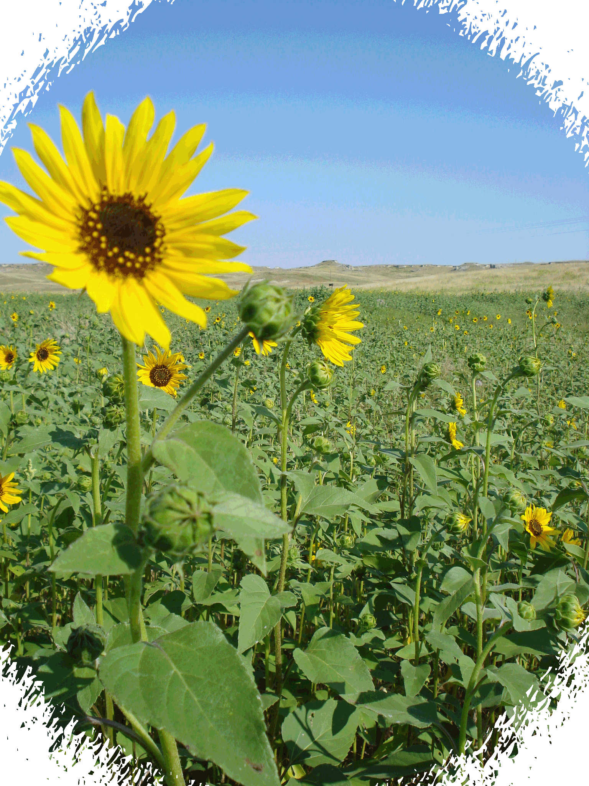
Nebraska can stop polluting and stop smoking. We can also stop hunting animals and stop cutting down trees and polluting the air.

Alexis

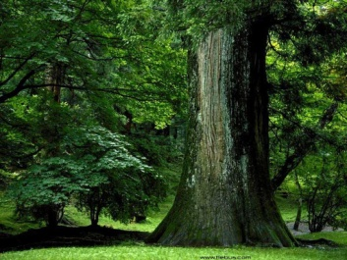
- In Nebraska we have Elm, Ash, Hardwoods, Ponderosa Pine, Oaks, Eastern Red cedar, Hardwood, Cottonwood, Willow, and Ag-forest planting forests. Some are located by lakes like the Zorinsky Lake. Others are located in some other places around other lakes and areas. Most forests are located in central and western Nebraska. There are some National forests here, too.
- Animals that live there include a bald eagle. It also includes sometimes a black bear. There’s also the white-tailed deer.
- Plants that grow there include Elm and Maple trees. It also includes the Pecan tree.
- Animals that are endangered in our forests include the whooping crane. It also includes the American buying beetle. I only listed some of the endangered animals in our forests. There aren’t very many endangered animals in our forests.
- To save forests we should not litter. We can also donate money to save them.

Lauren

One of the forests in Nebraska is Nebraska National Forest. It is a United States National Forest. Another forest in Nebraska is Samuel R. McKelvie National Forest. It is located in the north-central Sandhills.
The animals that live there are the black-footed ferret. There is also a prairie dog. There are also many more. All the animals in Nebraska forests are wild. The black-footed ferret is considered the most endangered animal in North America.
The plants that grow in Nebraska forests are grasses, forbs, shrubs, and trees. Many plants grow there. These plants though are most common in Nebraska forests.
One of the endangered animals is the black-footed ferret. Like I mentioned before they are the most endangered animal in North America. These animals are have the widest range of any endangered animal
To save the forests you can collect money and give it to a forest in Nebraska. We can also go to someone who works at a forest in Nebraska and ask them what you can do. There are many ways you can save the forests.

Brady
In Nebraska there are forests having lots of trees and plants. The trees are pretty tall with lots of leaves in the spring. There are different trees in our forests. We have no mountains in our forests. It is kind of flat with hills. We have a lot of birds like robins, eagles, hawks and other many birds. The most common snakes we have in our forests are Gardner snakes. We also have a lot of squirrels that live in our forests. There are also a lot of deer and turkey. Some plants in our forest are trees like maple trees, and a lot more. We have flowers like mums . There are also different types of grass. There are endangered animals in Nebraska. Some animals that are endangered are prairie dogs and black footed ferrets. We cannot cut down so many trees . We could save forests by not putting harmful toxins into the forests. We could also save forests by preventing wild fires.

Logan

- Here are the kinds of forest we have in Nebraska, there are no original trees but Nebraskans though trees where important so they made a national forest where they planted trees.
- The kinds of animals we have here are squirrels, deer, birds, frogs, crane, bison, and cats.
- The plants that grow here are the goldenrod, sunflower, American bellflower, common boneset, narrow-leaf coneflower ,and Virginia strawberry.
- The endangered animals we have in Nebraska are eagle, crane, beetle, ferret, curlew, and plover.
- The things we can do to save forest are using less paper, planting more trees, not littering, and not cutting down trees.

John

There aren’t many natural forests in Nebraska. The animals that live here are deer, foxes, turtles, and moose and all the animals at the zoo like tigers, bears and farm animals. They live in trees or at the zoo. The plants that grow here need a lot of water. Don’t burn down trees or recycle and do not us as much paper. Pick up litter on the street. Do not pollute. Find new idea’s to help the environment. Do not take as long as showers or don’t let the water run when you are brushing your teeth. Join a club to help keep the earth clean. Clean up trash at the beach if you live by one.

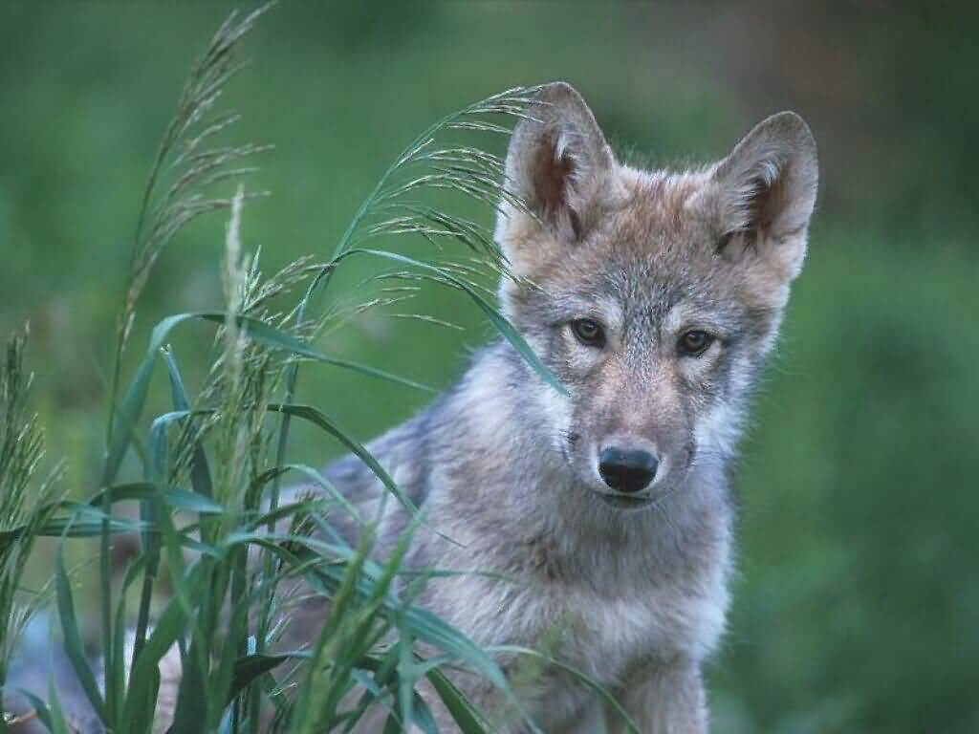

Jaden
1. Some forests in Nebraska are Fontenelle Forest. Here is a picture of it 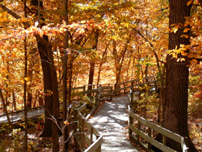
2. Some animals that live there are deer, bears and wild animals like that.
3. Some plants that grow there are trees, bushes and flowers and many more.
4. Some endangered animals are bald eagles, ferret black-footed, and piping plover .
5. To save forest we can stop cutting down trees and make homes for the animals.

Jack
Platte view forest and Mahoney forest are two names for managed forests here
We have all kinds of animals. Some we raise on farms like ostriches…others are wild, like turkeys. The sunflower is native here. In Nebraska yes there are endangered animals and one is the black-footed ferret. A way we can save forests is pick up litter and make it a non-hunting zone for all people.

