THE CLASSROOM SURVEY

Circle Name: Places and Perspectives or iearn - PPM1
Class Name: Class 8
School Name: Osnovna šola Cerklje ob Krki (Primary School)

PART I. INTRODUCING THE CLASS

A. Name of the teacher: Mrs Mojca Sterk
B. Grade level: Middle (6-9)
C. Class favorites (List your class top 5 favorites in each category):
1. Music groups: Metallica, One Direction, Bon Jovi, Skrilix, Rihanna
2. Authors: J.K. Rowling, Nicholas Spark, Mary Higginc Clark, Agatha Christie (Hiša noči)
3. TV programs: ‘Kanal A’, Discovery, Sportklub, Boomerang, MTV
4. Foods: kebab, hamburger, beef soup, steaks, pancakes
5. School subjects: English, Slovene, Maths, Music, P:E:
6. Sports: football, volleyball, downhill cycling, motorcross, handball, tennis
7. Video or computer games: Call of Duty, FIFA, Sims, GTA
8. Favorite Websites: youtube, facebook, twitter, gmail, 123igre, tumblr

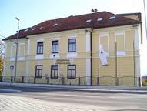
PART II. INTRODUCING THE SCHOOL

- School information

- Name and complete mailing address of class and school
School name: Osnovna sola Cerklje ob Krki
E-mail: http://sola.cerkljeobkrki.si/
Class mailing address: mojcasterk@yahoo.co.uk
- Number of students in class and school:
In this particular group of students there are only 9 students, 3 boys and 5 girls. Usually there are around 20 students per class.
There are around 200 students at school.
3. Size of school: 12 classrooms, a small elementary school
4. School emblem, colors or mascot
5. Type and number of computers: 10 computers

6. School history
It is situated in Cerklje ob Krki, a village near the river Krka, in the southern part of Posavje region.
In 1854 an old school was founded in the attic room of the ‘Marincek’ house. The old part of today’s school was built in 1904. Before WW2 there were 6 grades while it was empty during the war since all the local people were exported to German concentration camps and luckily it didn’t get damaged. In 1953 the school got 8 grades.
In 1973 it was renovated and a gym was added. Small renovations followed. Lots of new teaching aids and equipment were bought so that teachers and students can work in good conditions.
Now there are 9 grades (aged 6-15) in primary school and 4 groups in the kindergarten (aged 1-5) which is an integral part of school, and there are 230 children and 40 staff members altogether. The school activities take place in 11 classrooms and 5 cabinets plus a library, there’s a gym and one sport ground in the open air.
B. School program
- List 3 things about your school program that makes it unique:
- special attention is given to talented students as well as to those with special needs, not to mention the gypsies (we have programs and special lessons dedicated to all of those)
- many extracurricular activities are organized on the school premises, as well as a number of competitions covering almost all school subjects
- serious involvement in projects of all kinds, on the local, national as well as international level – in terms of English classes alone we’re active on www.etwinning.net and on www.iearn.org;
- List school calendar from the session dates (holidays and special events that may affect your participation):
- Autumn break (29 Oct – 4 Nov)
- New Year break (24 Dec – 1 Jan)

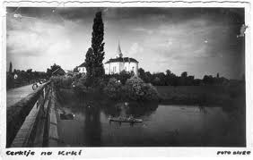
PART III. INTRODUCING THE COMMUNITY

A. Your community
1. Name of your community:
Cerklje ob Krki (‘ob’ means ‘next to’, so it’s ‘Cerklje next to the river Krka’)
2. If not a city, name and size of the nearest city: nearest towns are Krško and Brežice
3. Location of your community: Cerklje ob Krki is situated next to the river Krka, southwest of Brežice and south of Krško, two of the biggest towns in the region of Posavje. Cerklje ob Krki is the main village surrounded by 16 others. Posavje region lies in the eastern part of Slovenia, close to the Croatian border.
4. The area of your community: not big
5. The population of your community: Around 220 people live in the area.

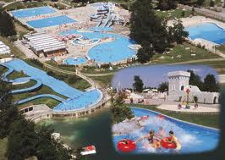
- Special characteristics

- List 3 reasons why people come to visit your area:
- Terme Spa in Čatež (near Brežice town) – the most famous Slovene spa
- Brežice castle and other historic sites
- Vineyards (the area is known for its special red wine called ‘cviček’)
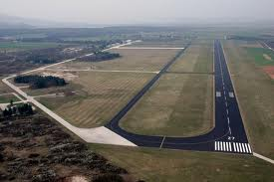
- There is an Air Force Base quite near our school so listening to the sound of helicopters is quite common.

C. Industries
List major industries or occupations in your community:
It is the most famous site in the area: the Nuclear Power Plant in Krško – we joke around that we all radiate at night
There are also a Pulp and Paper Industry, “Lisca” Fashion (underwear and swimsuits mainly), Furniture, Food and drink processing and others.

PART IV. OTHER INFORMATION
I’m an English teacher for grades 5-9 in a small elementary school (grades 1-9). I have a colleague helping me in class 8 and 9 (they are divided in two classes) but otherwise I’m alone for everything! It’s a big plus if you can be your own boss, but on the other hand it can get pretty overwhelming sometimes. It is stressful sometimes but I’m a big optimist and with lots of energy (that might be connected with the fact that I’m still quite young, I don’t know if I’ll be the same in 20 years time ). Plus I’m a supermom of three sweet little boys
I love learning new stuff connected with the teaching of English and have found that making projects is just the best thing I can offer to my students!
Looking forward to this new experience in a Learning circle
