The Classroom Survey --Getting to Know You!
Circle Name:
Class Name:
PART I. INTRODUCING THE CLASS
A. Name of teacher: Margarita Astakhova
B. Grade level: 6-7
C. Class favorites (List your class top 5 favorites in each category):
1. Music groups Skrilleks , Green day, The Beatles
2. Authors A.Pushkin , M,Lermontov, J.Rowling
3. TV programs News , Comedy Club , Galileo
4. Foods Pizza, ice cream , fast food, chocolate
5. School subjects English, Maths , PE , Art , Music
6. Sports runing, volleyball ,football, skiing
7. Video or computer games Flat out ultimate carnage, GTA
8. Favorite Websites vkontackte.ru, mail.ru , google.ru , macmillan.ru, facebook
9. Other Class Favorites of your choice hanging out with friends , dancing , playing the guitar

PART II. INTRODUCING THE SCHOOL
A. School information
1. Name and address of class and school:
Secondary school#7, 23,Octyabrskaya Street, Korolyov
2. Number of students in class and school:
25, 370
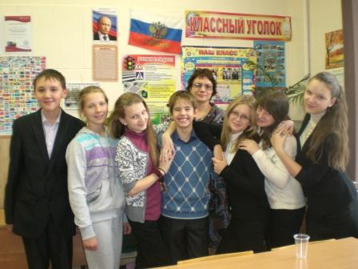
3. Size of school: a five- storey building with long corridors, which are very nice to run along.
4. School emblem, colors or mascot: We have a flag of our school. There is the Sun on the green background.
5. Type and number of computers 17 computers
6. School history. Our school is old. In a year it will be 60th birthday of our school.
B. School program
- List 3 things about your school program that make it unique
After classes we have an English hour. We have many interesting activities and projects. We have many unique and funny teachers in our school.
2. List school calendar from the session dates (holidays and special
events that may affect your participation).
1st September- first day of school.
5th October- Teachers Day.
5th-19th November- autumn holidays.
1st-14th January- winter holidays.
7th January- Christmas.
23rd February – Defenders’ Day.
8th March – Women’ Day.
Last week of March – spring holidays.
1st May – Labour Day.
9th May – the Victory Day
25th May – the last Day of school except for 9th and 11th graders (they have exams in June)
PART III. INTRODUCING THE COMMUNITY
A. Your community
1. Name of your community: the city of Korolyov
2. If not a city, name and size of nearest city
3. Location of your community: 7 km from Moscow
4. The area of your community
5. The population of your community: 200 000 people
B. Special characteristics
1. List 3 reasons why people come to visit your area.
Rocket building industry.
Nice people.
Space museums.
- Describe any unusual land formation found in or near your community.
We live near the most beautiful forest in the Moscow region, which is called Elk Island. Elk Island National Park is one of the oldest national parks in Russia. 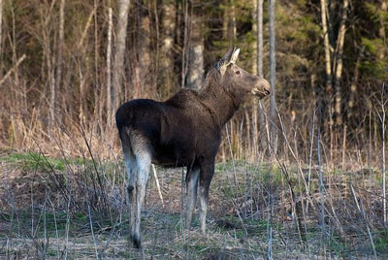
The National park is the natural habitat for hedgehogs, moles, shrews, storks, woodpeckers, muskrats, ducks, foxes, wolves, wild boars, deer, beavers, swans, and owls, snakes and squirrels.
C. Industries
List major industries or occupations in your community.
The city of Korolyov is the Russian centre of cosmonautics. The main industry is space-rocket building. The first artificial satellite, the first space station, and the first man-made spaceship were built in our city of Korolyov. Most parents of our students work in the space industry. The Russian space-rocket corporation “Energia” is one of the leading enterprises of the Russian space-rocket industry. It is the developer of the space piloted ships "Union", cargo devices «M progress» and communication satellites. It also directs the technical functioning of the International Space Station.
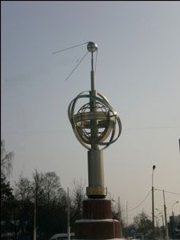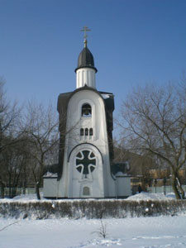
PART IV. OTHER INFORMATION
Please feel free to share any other information about yourself that you think would help us to know you better.

